

Semester One Examination, 2020

MATHEMATICS

SOLUTIONS
METHODS
UNIT 3

Section Two:

Calculator-assumed

Structure of this paper

Section | Number of  questions  available | Number of  questions to  be answered | Working  time  (minutes) | Marks  available | Percentage  of  examination
Section One:  Calculator-free | 8 | 8 | 50 | 52 | 35
Section Two:  Calculator-assumed | 13 | 13 | 100 | 98 | 65
 |  |  |  | Total | 100

This section has thirteen questions.

Question 9 (6 marks)
A seafood processor buys batches of $n$ prawns from their supplier, where $n$ is a constant. In any given batch, the probability that a prawn is export quality is $p$, where $p$ is a constant and the quality of an individual prawn is independent of other prawns.

The discrete random variable $X$ is the number of export quality prawns in a batch and the mean of $X$ is $220.5$ and standard deviation of $X$ is $5.25$.

(a) State the name given to the distribution of $X$ and determine its parameters $n$ and $p$.
(4 marks)
Solution
$X$ follows a binomial distribution.

$$np=220.5 \\ np\left(1-p\right)={5.25}^{2}$$

$$n=252, p=\frac{7}{8}=0.875$$

Specific behaviours
names binomial distribution
ü equation for mean and variance (or sd)
ü value of $n$
ü value of $p$

Done well with almost everyone recognising it as a Binomial Distribution (but we haven’t done many others at this time of the year!). This should have been an easy 4 marks.

(b) Determine the probability that less than $90\%$ of prawns in a randomly selected batch are export quality. (2 marks)
Solution
$$90\%×252=226.8$$

$$P\left(X≤226\right)=0.8753$$

Specific behaviours
lower bound
ü probability

Failure to work out what number of prawns were part of the calculation proved costly. Obviously, no follow-through marks could be considered.
Question 10 (8 marks)
A small body moving in a straight line has displacement $x$ cm from the origin at time $t$ seconds given by
$$x=4\cos\left(3t-6\right)-1.5, 0≤t≤3.$$

(a) Use derivatives to justify that the maximum displacement of the body occurs when $t=2$.
(4 marks)
Solution
$$\frac{dx}{dt}=-12\sin\left(3t-6\right) \\ t=2⇒\frac{dx}{dt}=-12\sin\left(0\right)=0$$
Hence when $t=2, x$ has a stationary point.

$$\frac{d^{2}x}{dt^{2}}=-36\cos\left(3t-6\right) \\ t=2⇒\frac{d^{2}x}{dt^{2}}=-36\cos\left(0\right)=-36$$
Since second derivative is negative, the stationary point is a maximum, and so the body has a maximum displacement when $t=2$.

Specific behaviours
first derivative
ü indicates stationary point at required time
ü value of second derivative at required time
ü statement that justifies maximum

It is surprising that students cannot differentiate simple trig functions – or keep the variables that appear in the question! The requirement to prove the stationary point is ever present and this should have been obvious given the mark allocation for this part of the question.
(b) Determine the time(s) when the velocity of the body is not changing. (2 marks)
Solution
$$a=\frac{d^{2}x}{dt^{2}}=-36\cos\left(3t-6\right)$$
$$a=0⇒\cos\left(3t-6\right)=0$$

$$t=2-\frac{π}{2},2- \frac{π}{6}, 2+\frac{π}{6}≈0.429, 1.476, 2.524 \text{seconds}$$

Specific behaviours
indicates acceleration/second derivative must be zero
ü states exact (or approximate) times in interval

This was done quite well by those who can differentiate trig functions and understand the relationship between trig angles in a unit circle. Or, can use their ClassPads!
(c) Express the acceleration of the body in terms of its displacement $x$. (2 marks)
Solution
$$a=-36\cos\left(3t-6\right) \\ =-9\left(4\cos\left(3t-6\right)\right) \\ =-9\left(x+1.5\right)$$

Specific behaviours
factors out $-9$
ü correct expression

This is a common type of question and students need to read the questions carefully. Finding ‘in terms’ of a stated variable is not interpretable and students should not expect markers to interpret an answer. A lot of students gave a mark away in this part!
Question 11 (8 marks)
The voltage, $V$ volts, supplied by a battery $t$ hours after timing began is given by

$$V=14.9e^{-0.355t}$$

(a) Determine
Solution
$$V\left(0\right)=14.9 \text{V}$$
Specific behaviours
correct value

(i) the initial voltage. (1 mark)

Solution
$$V\left(1.9\right)=7.59 \text{V}$$
Specific behaviours
correct value

(ii) the voltage after $1.9$ hours. (1 mark)

(iii) the time taken for the voltage to reach $0.01$ volts. (1 mark)
Solution
$$t=20.6 \text{h}$$
Specific behaviours
correct value

All parts were done well here.

(b) Show that $\begin{matrix}dV \\ \overline{dt}\end{matrix}=aV$ and state the value of the constant $a$. (2 marks)
Solution
$$\frac{dV}{dt}=-0.355\left(14.9e^{-0.355}\right) \\ =aV$$

$$a=-0.355$$
Specific behaviours
correct derivative
ü value of $a$

Done well by most.
(c) Determine the rate of change of voltage $1.9$ hours after timing began. (1 mark)
Solution
$$\dot{V}=-0.355×7.59 \\ =-2.69 \text{V/h}$$
Specific behaviours
correct rate

Again, done well.

(d) Determine the time at which the voltage is decreasing at $2\%$ of its initial rate of decrease.
(2 marks)
Solution
$$\dot{V}∝V⇒e^{-0.355t}=0.02$$

$$t=11.0 \text{h}$$

Specific behaviours
indicates suitable method
ü correct time

This whole question was done well overall. Just be careful that you have provided a reasonable answer in these type of questions and have also considered the mark allocation.

Question 12 (7 marks)
The function $f$ is defined as $f\left(x\right)=\begin{matrix}5e^{0.2x} \\ \overline{ x }\end{matrix} , x>0$, and the graph of $y=f(x)$ is shown below.
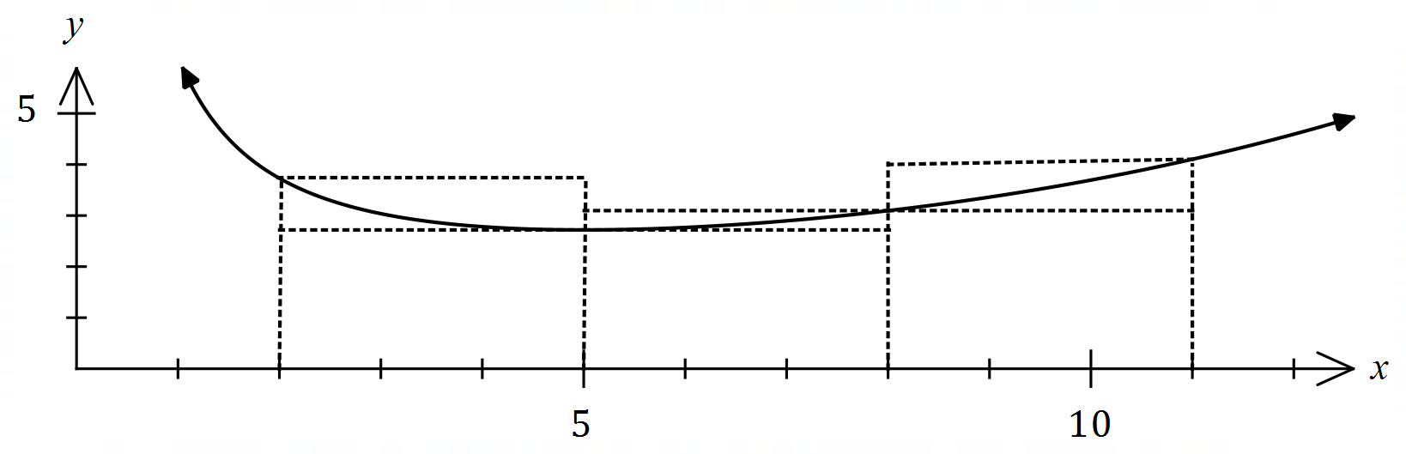
(a) Complete the missing values in the table below, rounding to $2$ decimal places. (1 mark)
Solution
See table
Specific behaviours
both correct

$$x$$ | $$2$$ | $$5$$ | $$8$$ | $$11$$
$$f(x)$$ | $$3.73$$ | $$2.72$$ | $$3.10$$ | $$4.10$$

An easy question for those that can substitute values and use their ClassPad! Both parts correct was necessary to get the single mark.

(b) Use the areas of the rectangles shown on the graph to determine an under- and over-estimate for $\int_{2}^{11}{\underset{ }{\overset{ }{f(x)}}}dx$. (3 marks)
Solution
$$U=3\left(2.72+2.72+3.1\right)=3×8.54=25.62$$

$$O=3\left(3.73+3.1+4.1\right)=3×10.93=32.79$$

Specific behaviours
indicates $δx=3$
ü under-estimate
ü over-estimate

Very pleasing to see that students recognised the fact that the change in x was not 1. It was a pity that careless errors cost many students marks here. The most common error was not recognising the same two upper values for the under-estimate.

(c) Use your answers to part (b) to obtain an estimate for $\int_{2}^{11}{\underset{ }{\overset{ }{f(x)}}}dx$. (1 mark)
Solution
$$E=\left(25.62+32.79\right)÷2≈29.2$$

Specific behaviours
correct mean

An easy mark that was also accorded a follow-through mark as long as the average calculation was shown.

(d) State whether your estimate in part (c) is too big or too small and suggest a modification to the numerical method employed to obtain a more accurate estimate. (2 marks)
Solution
Estimate is too big ($f(x)$ is concave upwards).

Better estimate can be found using a larger number of thinner rectangles.

Specific behaviours
states too big
ü indicates modification to improve estimate

Well done.

Question 13 (8 marks)
A bag contains four similar balls, one coloured red and three coloured green. A game consists of selecting two balls at random, one after the other and with the first replaced before the second is drawn. The random variable $X$ is the number of red balls selected in one game.

(a) Complete the probability distribution for $X$ below. (3 marks)

$$x$$ | $$0$$ | $$1$$ | $$2$$
$$P(X=x)$$ | $$\frac{9}{16}$$ | $$\frac{6}{16}$$ | $$\frac{1}{16}$$
Solution
$$P\left(X=0\right)={\left(\frac{3}{4}\right)}^{2}=\frac{9}{16}; P\left(X=2\right)={\left(\frac{1}{4}\right)}^{2}=\frac{1}{16}; P\left(X=1\right)=1-\frac{9+1}{16}=\frac{6}{16}$$

$$(0.5625, 0.375, 0.0625)$$
Specific behaviours
one correct probability
ü probabilities have sum of $1$
✓ all correct probabilities

This should have been an easy three marks for everyone who understood the procedure required. There was sufficient time here to do the problem in a number of ways. Done well overall.

(b) Determine $E(X)$ and $\operatorname{Var}{(X)}$. (2 marks)
Solution
$$E\left(X\right)=0+\frac{6}{16}+\frac{2}{16}=\frac{1}{2}; \operatorname{Var}\left(X\right)=\frac{3}{8}=0.375$$

NB Using CAS, $sd=\frac{\sqrt{6}}{4}≈0.6124$.

Specific behaviours
expected value
✓ variance

Done well. However, there were many students who then proceeded to find the standard deviation?

(c) A player wins a game if the two balls selected have the same colour. Determine the probability that a player wins no more than three times when they play five games.
(3 marks)
Solution
$$Y\sim B\left(5,\frac{10}{16}\right)$$

$$P\left(Y≤3\right)≈0.6185$$

Specific behaviours
defines distribution
ü states probability required
ü correct probability

Not done well. This is a very common type of question. The problem for many was the calculation/recognition of the correct probability for ‘same colour’. There were a couple of ways to calculate the correct answer.
Question 14 (8 marks)
A curve has equation $y=\left(x-3\right)e^{2x}$.

(a) Show that the curve has only one stationary point and use an algebraic method to determine its nature. (3 marks)
Solution
$$y^{'}=2xe^{2x}-5e^{2x} \\ =e^{2x}\left(2x-5\right)$$
For stationary point, require $y^{'}=0$ and since $e^{2x}≠0$ then $x=2.5$ - there is only one stationary point.

$$y^{''}=4xe^{2x}-8e^{2x}$$
$$x=2.5⇒y^{''}=2e^{5}$$
Hence stationary point is a local minimum.

Specific behaviours
first derivative
ü uses factored form to justify one stationary point
ü indicates minimum using derivatives (sign or 2nd)

Pleased that most recognised the need to use the Product Rule – and a couple of ways of getting the correct answer. Some forgot to show the ‘nature’ of the stationary point, but this part was generally well done.

(b) Justify that the curve has a point of inflection when $x=2$. (3 marks)
Solution
$$y^{''}=4e^{2x}\left(x-2\right) \\ y^{''}(2)=4e^{2(2)}\left(2-2\right)=0$$

Specific behaviours
shows second derivative is zero
ü explains justification

This was far too easy to be worth 3 marks!

(c) Sketch the curve on the axes below. (2 marks)

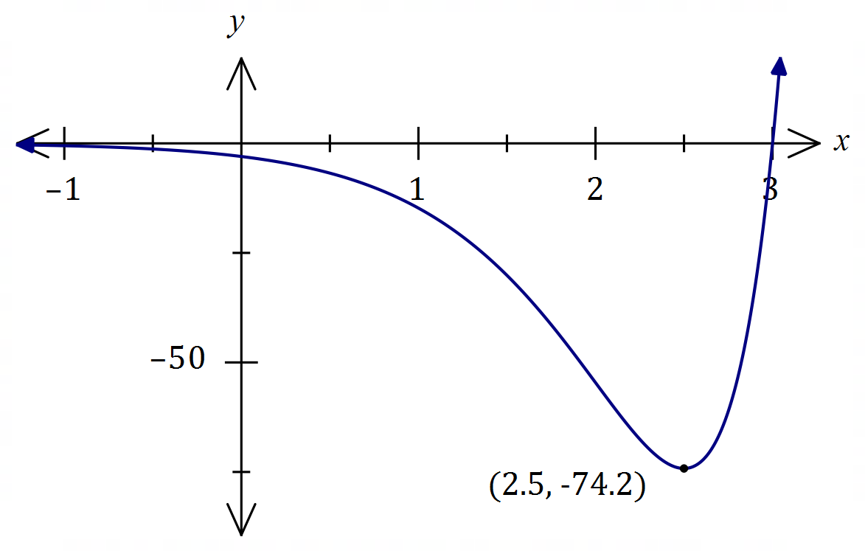
Solution
See graph
Specific behaviours
minimum, $y$-intercept
ü correct shape

As the equation was provided in the question and the ClassPad is available – how could you not get three marks for this question? Some didn’t !!!
Question 15 (9 marks)
A small body leaves point $P$ and travels in a straight line for $24$ seconds until it reaches point $Q$.
The velocity $v$ m/s of the body is shown in the graph below for $0≤t≤24$ seconds.

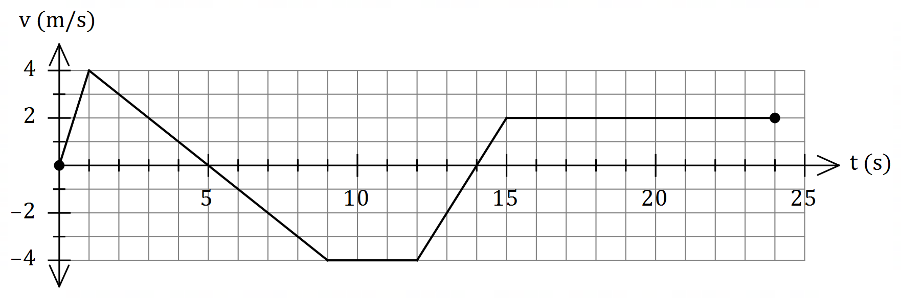

(a) Use the graph to evaluate $\int_{0}^{5}{\underset{ }{\overset{ }{v}}}dt$ and interpret your answer with reference to the motion of the small body. (3 marks)
Solution
$$\int_{0}^{5}{v}dt=\frac{1}{2}×5×4=10 \text{m}$$

The change in displacement of the body during the first $5$ seconds is $10$ m.
OR
The body has moved $10$ m to the right of $P$ during first $5$ seconds.

Specific behaviours
value of integral
ü interprets as change in displacement
ü includes specific time and distance with units in interpretation

The lack of understanding in this whole question was obvious. The inability to ‘read’ the question and understand what was required was also apparent. In this part, many students resorted to paragraphs about velocity and acceleration and missed the fundamental part of a V-T graph which is area is equal to displacement. It was necessary to mention ‘displacement’, to the right 10m AND how long it took! Words such as ‘forwards’ or ‘backwards’ are unacceptable unless the words are defined relative to the question.

(b) Determine an expression, in terms of $t$, for the displacement of the body relative to $P$ during the interval $1≤t≤9$. (3 marks)
Solution
$$v=5-t⇒x=\int{5-t}dt=5t-0.5t^{2}+c$$

$$t=1,x=2⇒2=5\left(1\right)-{0.5\left(1\right)}^{2}+c⇒c=-2.5$$

$$x=5t-{0.5t}^{2}-2.5, 1≤t≤9$$

Specific behaviours
expression for $v$
ü expression for $x$ with constant $c$
ü correct expression for $x$

Finding ‘c’ proved to be the major obstacle here, even if the student was able to identify the ‘line’ being considered. As with a couple of other parts in this examination, students needed a comprehensive understanding of linear equations.

(c) Determine the time(s) at which the body was at point $P$ for $0<t≤24$. (3 marks)
Solution
$$x\left(9\right)=10+\frac{1}{2}×4×\left(-4\right)=2$$
$$2-4\left(t-9\right)=0⇒t=9.5$$

$$x\left(15\right)=-13$$
$$-13+2\left(t-15\right)=0⇒t=21.5$$

Body at point $P$ when $t=9.5$ s and $t=21.5$ s.

Specific behaviours
indicates appropriate method using areas
ü one correct time
ü two correct times

If equating positive and negative areas was recognised as the appropriate method, it should have enabled students to get full marks here but that, unfortunately, was not the case.
Question 16 (9 marks)
When a machine is serviced, between $2$ and $6$ of its parts are replaced. Records indicate that $28\%$ of machines need $4$ parts replaced, $13\%$ need $5$ parts replaced, $5\%$ need $6$ parts replaced, and the mean number of parts replaced per service is $3.54$.

Let the random variable $X$ be the number of parts that need replacing when a randomly selected machine is serviced.

(a) Complete the probability distribution table for $X$ below. (4 marks)

$$x$$ | $$2$$ | $$3$$ | $$4$$ | $$5$$ | $$6$$
$$P(X=x)$$ | $$0.15$$ | $$0.39$$ | $$0.28$$ | $$0.13$$ | $$0.05$$

Solution
Let $P\left(x=2\right)=a, P\left(X=3\right)=b$ then

$$0.46+a+b=1 \\ 2a+3b+1.12+0.65+0.3=3.54$$
Hence
$$a=0.15, b=0.39$$

Specific behaviours
values for $x=4, 5, 6$
ü equation using sum of probabilities
ü equation using expected value
ü values for $x=2, 3$

Filling in the table was worth two marks and showing the simultaneous equations needed to be shown for the other two marks. This part was done well and the whole question proved to be one of the easiest on the whole paper.

Solution
Using CAS, $σ=1.0528058$

Hence $Var\left(X\right)=σ^{2}=1.1084$

Specific behaviours
indicates sd using CAS
ü correct variance

(b) Determine $Var⁡(X)$. (2 marks)

An easy two marks with the use of the ClassPad.

The cost of servicing a machine is $\$85$ plus $\$26.50$ per part replaced and the random variable $Y$ is the cost of servicing a randomly selected machine.

(c) Determine the mean and standard deviation of $Y$. (3 marks)
Solution
$$Y=85+26.5X$$

$$E\left(Y\right)=85+26.5×3.54=\$178.81$$

$$σ_{Y}=26.5×1.0528≈\$27.90$$

Specific behaviours
equation relating $X$ and $Y$
ü mean
ü standard deviation (penalty no units: $-1$ mark)

Some students were penalised a mark here for not showing the $ sign twice or giving answers to more than two decimal places. Otherwise, done very well.

Question 17 (6 marks)
Some values of the polynomial function $f$ are shown in the table below:

$$x$$ | $$1$$ | $$2$$ | $$3$$ | $$4$$ | $$5$$ | $$6$$ | $$7$$
$$f(x)$$ | $$16$$ | $$13$$ | $$8$$ | $$2$$ | $$-2$$ | $$1$$ | $$5$$

(a) Evaluate $\int_{1}^{6}{\underset{ }{\overset{ }{f'(x)}}}dx$. (2 marks)
Solution
$$\int_{1}^{6}{f^{'}\left(x\right)}dx=f\left(6\right)-f\left(1\right) \\ =1-16 \\ =-15$$

Specific behaviours
uses fundamental theorem
ü correct value

This was done very poorly. Students showed a complete lack of understanding regarding the FFT of calculus. The only thing that needed to be recognised was that the integral of a derivative, results in the original function. By using the equation that is provided on the Formula Sheet it was merely a question of substitution!

The following is also known about $f'(x)$:

Interval | $$1≤x≤5$$ | $$x=5$$ | $$5≤x≤7$$
$$f'(x)$$ | $$f^{'}\left(x\right)<0$$ | $$f^{'}\left(x\right)=0$$ | $$f^{'}\left(x\right)>0$$

(b) Determine the area between the curve $y=f'(x)$ and the $x$-axis, bounded by $x=2$ and $x=7$. (4 marks)
Solution
Area to right of $x=5$ is above axis but to left is below so will need to negate/drop negative sign for that integral:

$$\text{Area}=-\int_{2}^{5}{f^{'}\left(x\right)}dx+\int_{5}^{7}{f^{'}\left(x\right)}dx \\ =-\left[f\left(5\right)-f\left(2\right)\right]+\left[f\left(7\right)-f\left(5\right)\right] \\ =f\left(2\right)+f\left(7\right)-2f\left(5\right) \\ =13+5-2\left(-2\right) \\ =22 \text{sq units}$$

Specific behaviours
ü integral for $f^{'}\left(x\right)<5$
ü negated integral for $f^{'}\left(x\right)>5$
ü uses fundamental theorem
ü correct area

Most missed the fact that there were two parts to the function. Any student who tried to do this in one step did not consider the fact it was worth 4 marks.
Question 18 (8 marks)
Let $P(a, b)$ be a point in the first quadrant that lies on the curve $y=5-x^{2}$ and $A$ be the area of the triangle formed by the tangent to the curve at $P$ and the coordinate axes.

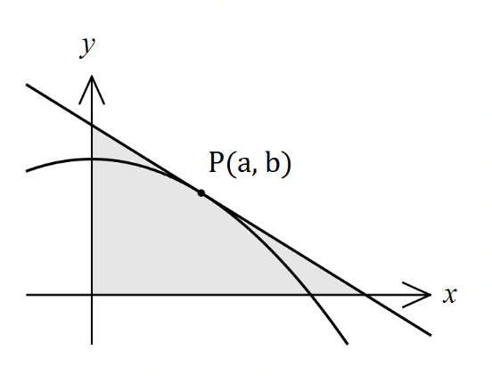

(a) Show that $A=\begin{matrix}{\left(a^{2}+5\right)}^{2} \\ \overline{ 4a }\end{matrix}$. (4 marks)

Solution
Gradient at $P$:
$$\frac{dy}{dx}=-2x⇒m_{P}=-2a$$
Equation of tangent:
$$y=-2ax + c \\ b=5 - a^{2}$$
$$⇒5 -{ a}^{2} ={-2a}^{2}+c$$
$$⇒c =a^{2}+5$$
Thus$y=-2ax + a^{2}+5$
Axes intercepts:
$$y=0⇒x=\frac{a^{2}+5}{2a}, x=0⇒y=a^{2}+5$$
Area:
$$A=\frac{1}{2}\left(\frac{a^{2}+5}{2a}\right)\left(a^{2}+5\right)=\frac{{\left(a^{2}+5\right)}^{2}}{4a}$$

Specific behaviours
$b$ in terms of $a$ and $m_{P}$
ü equation of tangent in terms of $a, x, y$ (any form)
ü axes intercepts
ü indicates area of right triangle

Very poorly done and not surprising given the fact that it was quite a unique question that expected students to remember a lot about intersections, gradient, intercepts, etc. It was more a question of algebraic manipulation rather than a straight calculus question. The focus was on finding the area of a triangle, so it was necessary to find the base and the height. This simple fact was missed by almost everyone, which resulted in a range of algebraic nonsense that went nowhere.

(b) Use calculus to determine the coordinates of $P$ that minimise $A$. (4 marks)
Solution
$$\frac{dA}{da}=\frac{3a^{4}+10a^{2}-25}{4a^{2}}$$
$$\frac{dA}{da}=0⇒a=\frac{\sqrt{15}}{3}≈1.291$$

$$\frac{d^{2}A}{da^{2}}={\left.\frac{3a^{4}+25}{2a^{3}}\right|}_{a=\frac{\sqrt{15}}{3}}=2\sqrt{15}⇒\text{Minimum}$$
$$b=5-a^{2}=\frac{10}{3}$$
Hence $P\left(\frac{\sqrt{15}}{3},\frac{10}{3}\right)≈P(1.291, 3.333)$

Specific behaviours
first derivative
ü solves for $a$
ü indicates check for minimum (graph, sign or second derivative test)
ü correct coordinates, exact or at least $2$ dp

This question allowed students to get half the marks for the whole question because the function that needed differentiating was provided in part (a). Most were successful in getting the x-value but then made a mistake in getting the other ordinate. It was pleasing to see that students generally showed the fact that the point was a minimum.

Question 19 (7 marks)
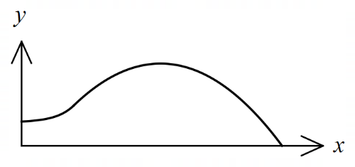
The edges of a swimming pool design, when viewed
from above, are the $x$-axis, the $y$-axis and the curves

$y=-0.1x^{2}+1.6x-1.5$ and $y=1.4+e^{x-3}$

where $x$ and $y$ are measured in metres.

(a) Determine the gradient of the curve at the point where the two curves meet. (2 marks)
Solution
Curves intersect when $x=3$

$$y^{'}=-0.2\left(3\right)+1.6=e^{3-3}=1$$

Specific behaviours
$x$-coordinate of intersection
ü correct gradient

An easy two marks for those with sufficient algebra skills. Failure to get the correct x value for the intersection affected other parts of the question and consumed time that did not match the worth of the question.

(b) Determine the surface area of the swimming pool. (4 marks)
Solution
$$A_{1}=\int_{0}^{3}{1.4+e^{x-3}}dx=\frac{26}{5}-\frac{1}{e^{3}}≈5.15$$

$$A_{2}=\int_{3}^{15}{-0.1x^{2}+1.6x-1.5}dx=\frac{216}{5}=43.2$$

$$A_{1}+A_{2}=\frac{242}{5}-\frac{1}{e^{3}}≈48.35 {\text{m}}^{2}$$

Specific behaviours
upper bound for parabola
ü area $A_{1}$
ü area $A_{2}$
ü total area, with units

Many students made a reasonable attempt at this question as it was clear what was being asked. However, the use of algebra caused issues and many students got only one of the two parts correct.

(c) Given that the water in the pool has a uniform depth of $145$ cm, determine the capacity of the pool in kilolitres ($1$ kilolitre of water occupies a volume of $1$ m³). (1 mark)
Solution
$$C=48.35×1.45≈70.1 \text{kL}$$

Specific behaviours
correct capacity

Many students forgot to convert units and ended up with some VERY large pools. Being only worth one mark, it was difficult to give any follow-through marks when answers are so obviously unreasonable.
Question 20 (6 marks)
Given that $f\left(3\right)=9, f^{'}\left(3\right)=-6, g\left(3\right)=-2$ and $g^{'}\left(3\right)=4$, evaluate $h'(3)$ in each of the following cases:

(a) $h\left(x\right)=g\left(x\right)⋅f(x)$. (2 marks)
Solution
$$h^{'}\left(3\right)=g^{'}\left(3\right)×f\left(3\right)+g\left(3\right)×f^{'}\left(3\right) \\ =4×9+\left(-2\right)×\left(-6\right) \\ =48$$

Specific behaviours
uses product rule
ü correct value

By far this was the question that caused the most problems for students. The concern here is the fact that students completely ignored the skills of basic algebra and failed to see it was just the Product Rule of differentiation with all the values provided. There hasn’t been a problem like this on previous papers, so students failed to even recognise what was required.

(b) $h\left(x\right)=g\left(\sqrt{f\left(x\right)}\right)$. (4 marks)
Solution
$$\frac{d}{dx}\sqrt{f\left(x\right)}=\frac{1}{2\sqrt{f\left(x\right)}}⋅f^{'}\left(x\right)$$

$$h^{'}\left(x\right)=g^{'}\left(\sqrt{f\left(x\right)}\right)×\frac{1}{2\sqrt{f\left(x\right)}}⋅f^{'}\left(x\right) \\ h^{'}\left(3\right)=g^{'}\left(\sqrt{f(3)}\right)×\frac{1}{2\sqrt{f(3)}}×f'(3)$$
$$=g^{'}\left(\sqrt{9}\right)×\frac{1}{2\sqrt{9}}×(-6) \\ =g'(3)×(-1) \\ =-4$$

Specific behaviours
uses chain rule on $\sqrt{f\left(x\right)}$
ü correct derivative of inside
ü uses chain rule again
ü substitutes and simplifies

Similar to part (a) but now with the Chain rule (twice) and a couple of extra steps!!
Question 21 (8 marks)
When a byte of data is sent through a network in binary form (a sequence of bits - $0$'s and $1$'s), there is a chance of bit errors that corrupt the byte, i.e. a $0$ becomes a $1$ and vice versa.

Suppose a byte consists of a sequence of $9$bits and for a particular network, the chance of a bit error is $0.200\%.$

(a) Determine the probability that a byte is transmitted without corruption, rounding your answer to $5$ decimal places. (3 marks)
Solution
$$X\sim B(9, 0.002)$$

$$P\left(X=0\right)=0.98214$$

Specific behaviours
indicates binomial distribution
ü indicates probability to calculate
ü correct probability, to $5$ dp

Generally done well and was interpreted correctly by most. Full marks were given for just the correct answer as this could be done quite easily on the ClassPad.

(b) Determine the probability that during the transmission of $128$ bytes, at least one of the bytes becomes corrupted. (2 marks)
Solution
$$Y\sim B\left(128, 0.01786\right)$$

$$P\left(Y≥1\right)=0.9004$$

Specific behaviours
indicates correct method
ü correct probability

There were a few interpretations of the question here due to the wording and therefore a couple of correct ways of getting the answer.

A Hamming code converts a byte of $9$ bits into a byte of $13$ bits for transmission, with the advantage that if just one bit error occurs during transmission, it can be detected and corrected.

(c) Determine the probability that during the transmission of $128$ bytes using Hamming codes, at least one of the bytes becomes permanently corrupted. (3 marks)
Solution
$$H\sim B\left(13, 0.002\right)$$

$$P\left(H≥2\right)=0.00031$$

$$M\sim B\left(128, 0.00031\right)⇒P\left(M≥1\right)=0.0386$$

Specific behaviours
ü states distribution of failures of a $13$ bit byte
probability that single Hamming code byte corrupted
ü correct probability

Not done well – largely due to the interpretation of the question. There were a number of ‘distractors’ in the wording that meant students were unsure of what was actually being asked.
Supplementary page

Question number: _________

